**Name-Ujjawal Mandhani**

**Batch-F6**

**Enroll No.-9918103237**

**OSS Lab-5**

**Question 1:**Plot tan(x), cot(x), sec(x) and cosec(x) for the values of x= [-pi,-pi/4, -pi/2, 0, pi/4, pi/2, pi].

**tan(x)**

**import numpy as np**

**X = [-np.pi,-np.pi/4, -np.pi/2,0, np.pi/4, np.pi/2,np.pi]**

**C = np.tan(X)**

**import matplotlib.pyplot as plt**

**plt.plot(X, C)**

**plt.show()**

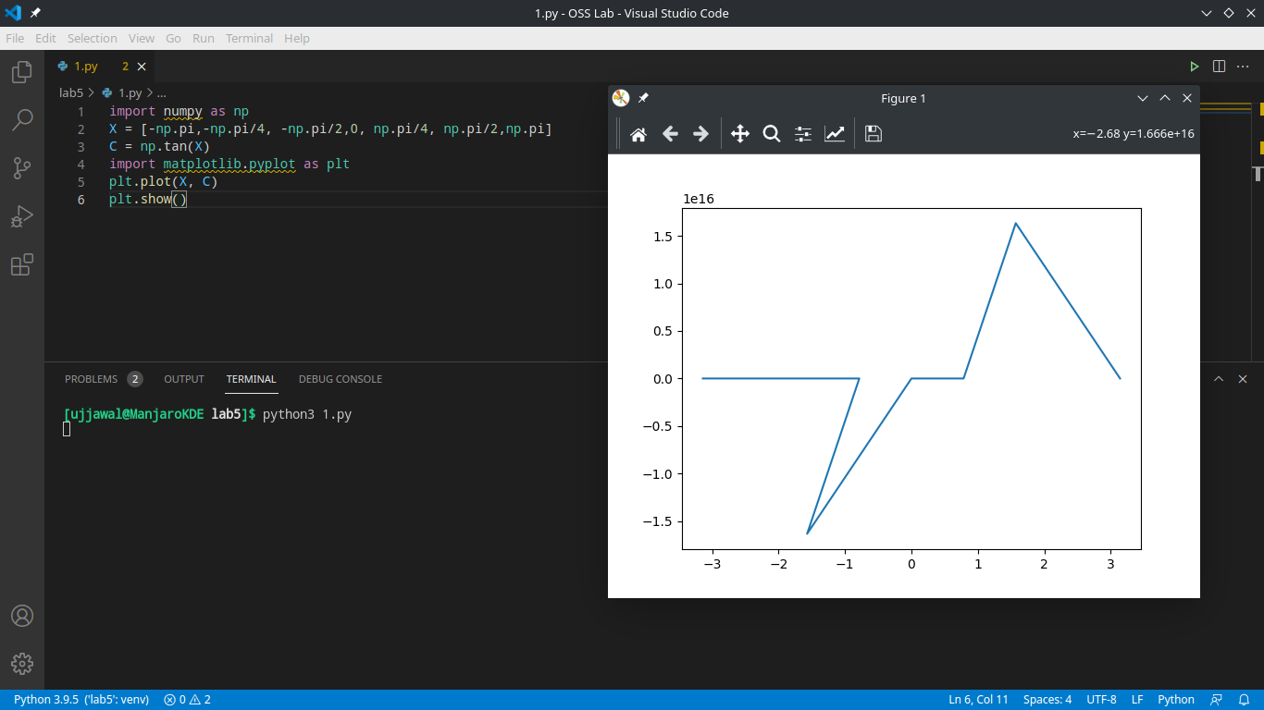

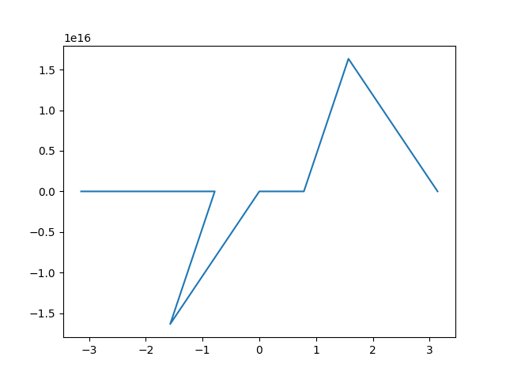

**Question 1.1**

**cot(x)**

**import matplotlib.pyplot as plt**

**import numpy as np**

**X = [-np.pi, -np.pi/4, -np.pi/2, 0, np.pi/4, np.pi/2, np.pi]**

**C = 1/np.tan(X)**

**plt.plot(X, C)**

**plt.show()**

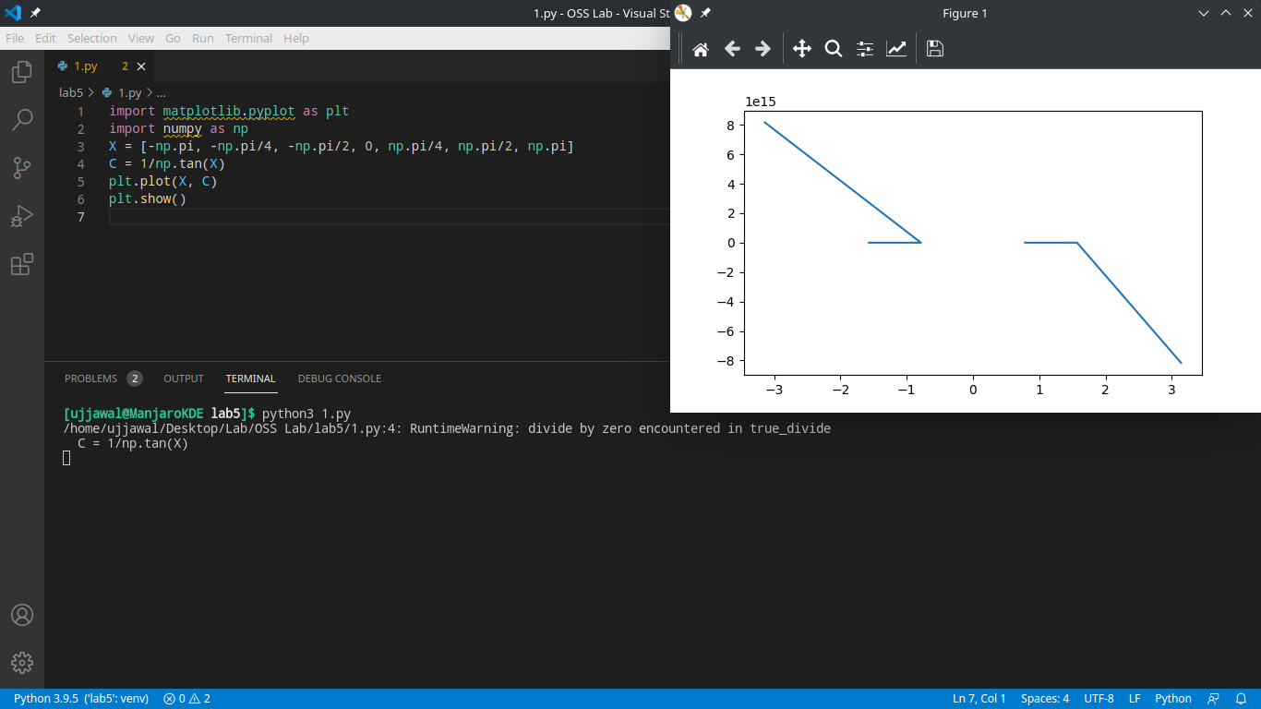 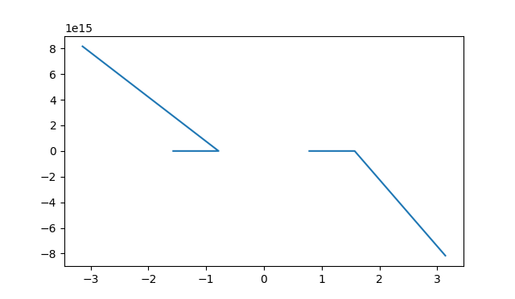

**Question 1.2**

**sec(x)**

import matplotlib.pyplot as plt

**import numpy as np**

**X = [-np.pi, -np.pi/4, -np.pi/2, 0, np.pi/4, np.pi/2, np.pi]**

**C = 1/np.sin(X)**

**plt.plot(X, C)**

**plt.show()**

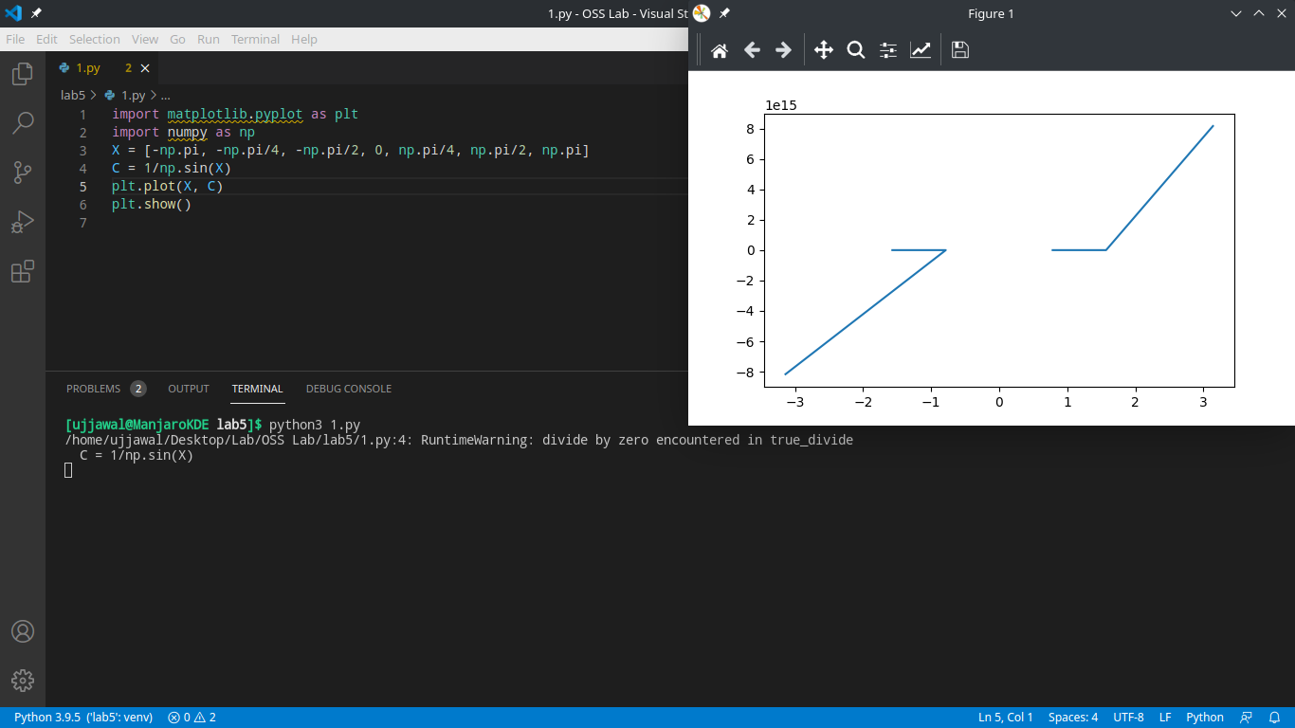

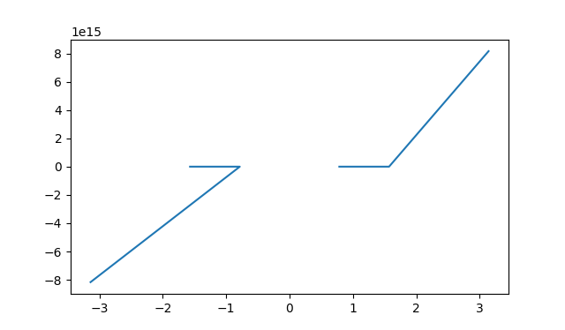

**Question 1.3:**

**cosec(x)**

import matplotlib.pyplot as plt

**import numpy as np**

**X = [-np.pi, -np.pi/4, -np.pi/2, 0, np.pi/4, np.pi/2, np.pi]**

**C = 1/np.cos(X)**

**plt.plot(X, C)**

**plt.show()**

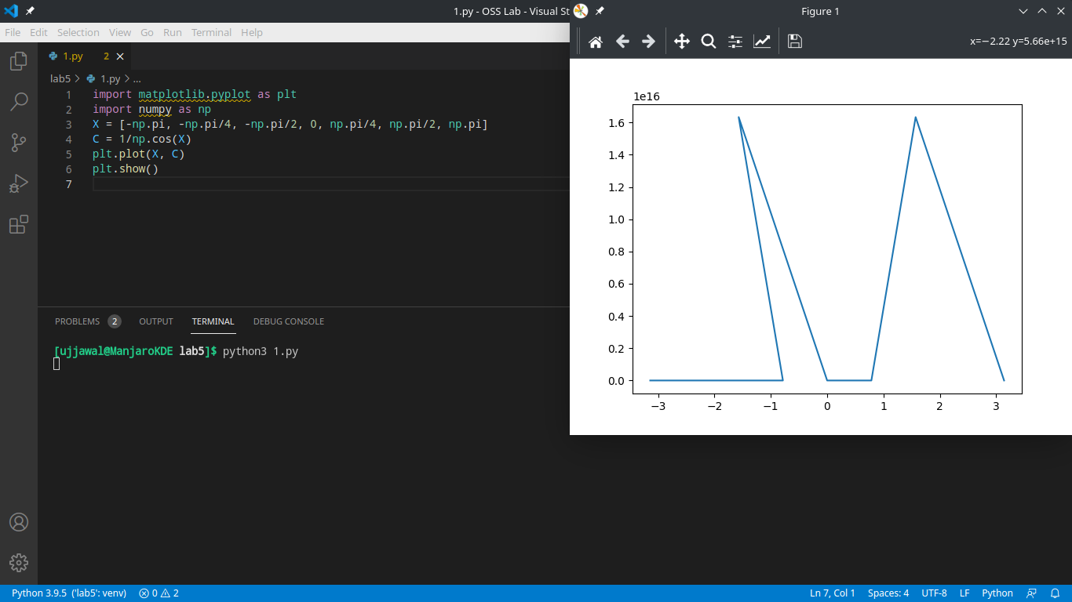

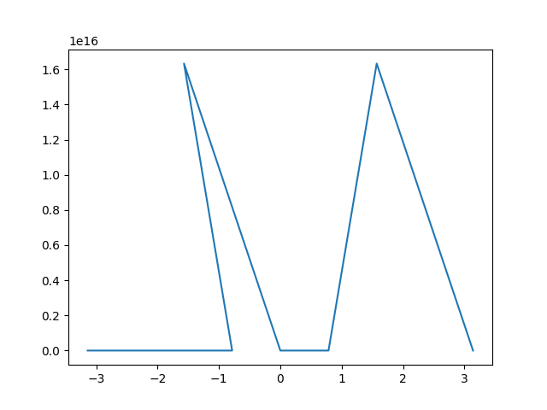

**Question 2:**Represent the following table using bar chart:

|  |  |  |
| --- | --- | --- |
| **Method** | **Result1** | **Result2** |
| A | 2 | 3 |
| B | 5 | 2 |
| C | 8 | 5 |
| D | 5 | 7 |

**import numpy as npi**

**import matplotlib.pyplot as plt**

**import pandas as pd**

**df = pd.DataFrame({"Method": ['A', 'B', 'C', 'D'], "Result1": [**

**2, 5, 8, 5], "Result2": [3, 2, 5, 7]})**

**df.plot(x="Method", y=["Result1", "Result2"], kind="bar")**

**plt.show()**

